**Online Education Employment Project (Website)**

**Final Report**

VEL Team

Date: 04/OCT/2015

Document Modification History/Revision log

|  |  |  |  |
| --- | --- | --- | --- |
| Version | Date | Author | Description of Change |
| 1.0 | 04/10/2015 | Shawn | Initial version |
|  |  |  |  |
|  |  |  |  |
|  |  |  |  |
|  |  |  |  |

Content

Project Description: 1

Delivered Software Increment 2

Completed Product Backlog 2

Sprint Backlog 4

Prototype Details 6

NUnit Tests 14

Mobile Friendly Test (Google) 14

Scrum Management 15

Sprint Review 17

Retrospective 17

Group Evaluation: 18

Project Description:

The goal of this project is to create an adaptive (mobile friendly) website to help IT students and unemployed people to get useful skills. The home page should draw visitors’ attention so that they would like to register as fixed users. And users can choose the courses they want to take according to some success stories. We use the .NET Framework and the Visual Studio development environment to develop the website.

|  |  |  |  |  |
| --- | --- | --- | --- | --- |
| *No.* | *GitHub username* | *SeeNowDo* | *Official name* | *UPI* |
| *1* | gaoyiqun | Irene | Yiqun Gao | YGAO742 |
| *2* | huajinxie | Kaii | Huajin Xie | HXIE519 |
| *3* | likaihe | Likai | Likai He | LHE838 |
| *4* | lulujing | LuLu | Jing Lu | JLU986 |
| *5* | vasanthnewzealand | V | Vasanth Boraiyan | VBOR051 |
| *6* | yazang | Clay | Chen Yang | CYAN988 |
| *7* | yinqi522 | Miranda | Yu Guo | YGUO425 |
| *8* | YsqEvilmax | Shawn | Shaoqing Yu | SYU702 |

Delivered Software Increment

Our team have finished 6 user stories in the product backlog in the past Sprint. The prototype is a website include Login function, Admin function, homepages, Success story list pages and detail pages. This website use a 3 tier architecture. Communication and data exchange between the 3 layers can be easily achieved with Model-View-Controller (MVC 5) patterns. The presentation layer, business logic layer and database layer, can be easily developed and maintained separately by using MVC 5. We’ve also redesigned Database, to ensure that no conflict in the DB integration.

Currently completed pages and functions in the prototype can be tracked through two flows – Admin flow and Visitor flow:

From the Admin Flow: Homepages 🡪 Login page (Admin) 🡪 Success Story List Admin Pages 🡪 Success Story Detail Admin pages 🡪 Success Story Detail Admin Pages (Add/Edit/Delete) 🡪 Success Story List Admin Pages

Form the Visitor Flow:

1. Homepages 🡪 Success Story List Pages 🡪 Success Story Detail Pages
2. Homepages 🡪 Team Profile Pages 🡪 FAQs Pages

Completed Product Backlog

|  |  |  |  |
| --- | --- | --- | --- |
| **No.** | **Completed User Stories** |  | **Relative tasks** |
| 1. | As a CEO, I want the main page could be brief but interesting. | So that visitors can be attracted. | (Home pages) |
| 2. | As the CEO, I want my customs can share their story page through social networks such as Facebook, Twitter, Google+ and LinkedIn. | So that they can promote our company. | (Success stories list page) |
| 3. | As the CEO, I want to put my team member's LinkedIn link on team profile page. | So that people can gain more confidence about our profession and experience. | (Team profile index page) |
| 4. | As a Visitor, I want an individual page to demonstrate the functionalities of the automation testing tool. | So that I can decide whether to study or not. | (Automation testing toll page) |
| 5. | As a visitor, I want to leave messages on the website. | So that I can get contact with the company. | (Home page) |
| 6. | As a CEO, I want to know how to make my website stand out from google searching results. | So that I can change the keywords with some strategies. | (Research report) |

Sprint Backlog

|  |  |  |  |  |  |  |
| --- | --- | --- | --- | --- | --- | --- |
| Story  ID | User Story | Task  ID | Task | Owner &  Participant | UPI | Hours |
| 1 | Refine Home Page | 11 | Change carousel to success story & Height | ClayY | CYAN988 | 5.0 |
|  |  | 12 | Website statistics | Irene | YGAO742 | 3.0 |
|  |  | 13 | UT for carousel | Shawn | SYU702 | 2.5 |
|  |  | 14 | UT for website statistics | LikaiH | LHE838 | 1.5 |
| 2 | Refine Success Story List | 21 | Share icons for social media | Shawn | SYU702 | 6.0 |
|  |  | 22 | Refine success story list page | Lulu | JLU986 | 3.0 |
|  |  | 23 | Refine detail page | Lulu |  | 4.0 |
|  |  | 24 | Unit Test (Story List) | Irene | YGAO742 | 1.0 |
| 3 | Team Profile Admin Function | 45 | Detail Success Story Page | ClayY | CYAN988 | 4.0 |
|  |  | 46 | Test Case (Story Detail) | Miranda | YGUO425 | 3.0 |
|  |  | 47 | Unit Test (Story Detail) | Miranda | YGUO425 | 2.0 |
| 4 | Test Automation Page | 48 | Team profile page | ClayY | CYAN988 | 2.0 |
|  |  | 49 | FAQ page | LikaiH | LHE838 | 2.0 |
| 5 | Contact Function | 51 | Admin (List page) | Kaii | HXIE519 | 9.0 |
|  |  | 52 | Admin (Edit page) | Kaii | HXIE519 | 8.0 |
|  |  | 53 | Admin (Add page) | V | VBOR051 | 7.0 |
|  |  | 53 | Admin (Add page) | Kaii | HXIE519 | 1.0 |
|  |  | 54 | Test Case & NUnit (Add) | Miranda | YGUO425 | 4.0 |
|  |  | 55 | Test Case & NUnit (Edit) | Miranda | YGUO425 | 4.0 |
|  |  | 56 | Test Case & NUnit (List) | Lulu | JLU986 | 4.0 |
|  |  | 57 | Unit Test (Story Detail) | Lulu | JLU986 | 3.0 |
|  |  | 58 | Admin (Delete page) | Kaii | HXIE519 | 3.0 |
| 6 | Google Search Keyword | 61 | Login Page | Miranda | YGUO425 | 6.0 |
|  |  | 62 | Test Case & Nunit (Login) | Irene | YGAO742 | 4.0 |
|  |  | 63 | Unit Test (Login) | Irene | YGAO742 | 1.0 |
| X1 | Scrum Activities | 01 | Client Meeting(25/08/2015) | ALL members |  | 4.0 |
|  |  | 02 | Scrum board init | Kaii | HXIE519 | 1.0 |
|  |  | 03 | Draft tasks list | Kaii | HXIE519 | 1.0 |
|  |  | 91 | Daily Scrum (28/08/2015) | ALL members |  | 1.0 |
|  |  | 92 | Daily Scrum (02/09/2015) | ALL members |  | 1.0 |
|  |  | 93 | Daily Scrum (05/09/2015) | ALL members |  | 1.0 |
|  |  | 94 | Daily Scrum (08/09/2015) | ALL members |  | 1.0 |
|  |  | 95 | Daily Scrum (11/09/2015) | ALL members |  | 1.0 |
|  |  | 96 | Retrospective Meeting | ALL members |  | 4.0 |
|  |  | 97 | Client review Meeting(14/09/2015) | ALL members |  | 6.0 |
|  |  | 98 | Client review Meeting(14/09/2015) | ALL members |  | 2.0 |

Sprint 2 Details

1. User Story 1: Refined home page

URL: <http://getskills.azurewebsites.net/>

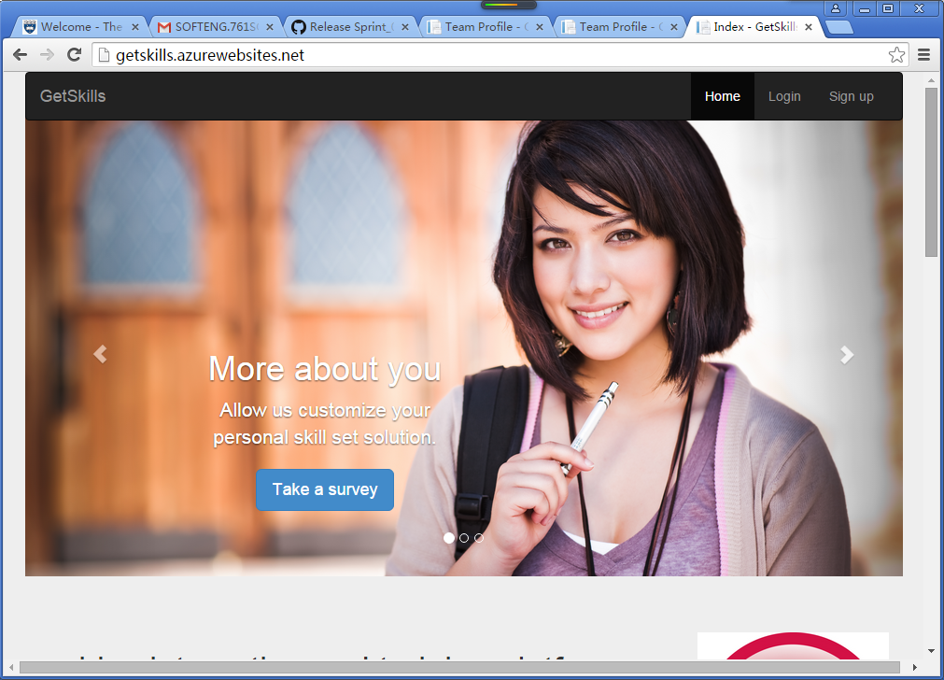

1. User Story 2: As a VISITOR (anonymous user), I would like to read some success stories of previous students.

** At the bottom of the Home Page (<http://getskills.azurewebsites.net/>), there is a link – “Success Stories” located in “Site Map” zone.

URL: <http://getskills.azurewebsites.net/SuccessStory/List>

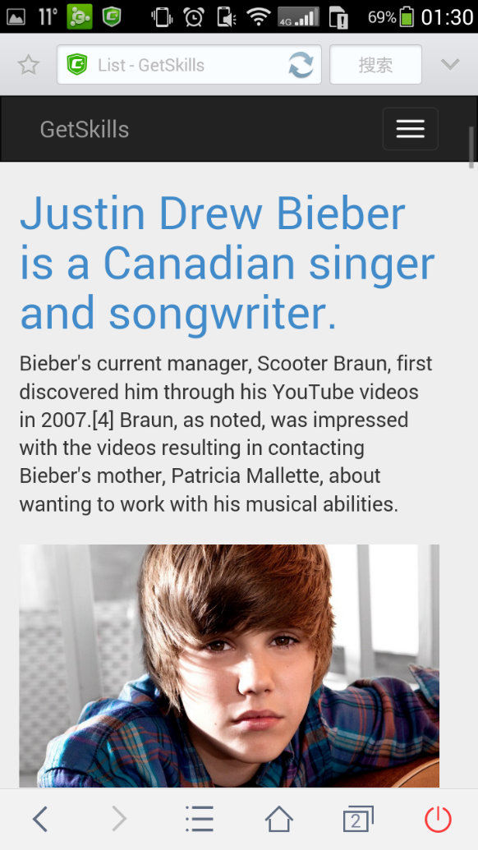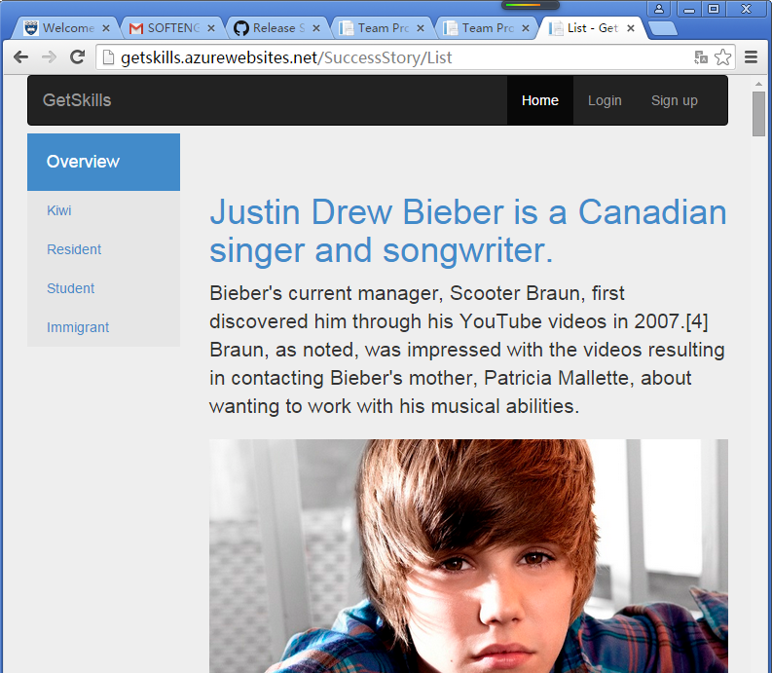

1. User Story 3: As a VISITOR (anonymous user), I would like to read the details of some success stories.

** Click the title of each success story in Success Stories List Page (<http://getskills.azurewebsites.net/SuccessStory/List>), the pages will navigate to the relative Success Story Detail Pages. Visitors can jump back to the Success Stories List Pages by clicking ‘Back to list’ link at bottom.

URL: For example: <http://getskills.azurewebsites.net/SuccessStory/Detail/2>, or <http://getskills.azurewebsites.net/SuccessStory/Detail/1>

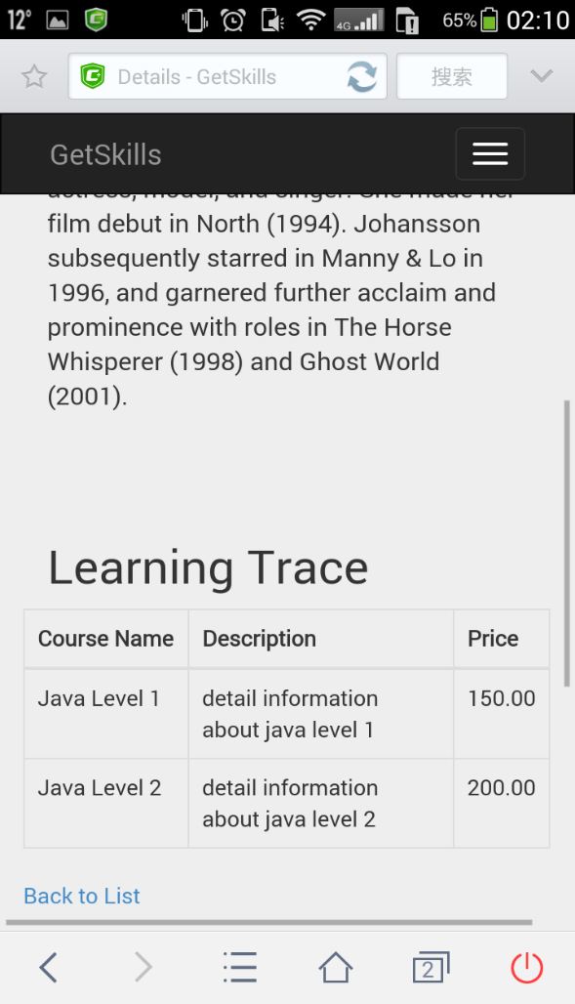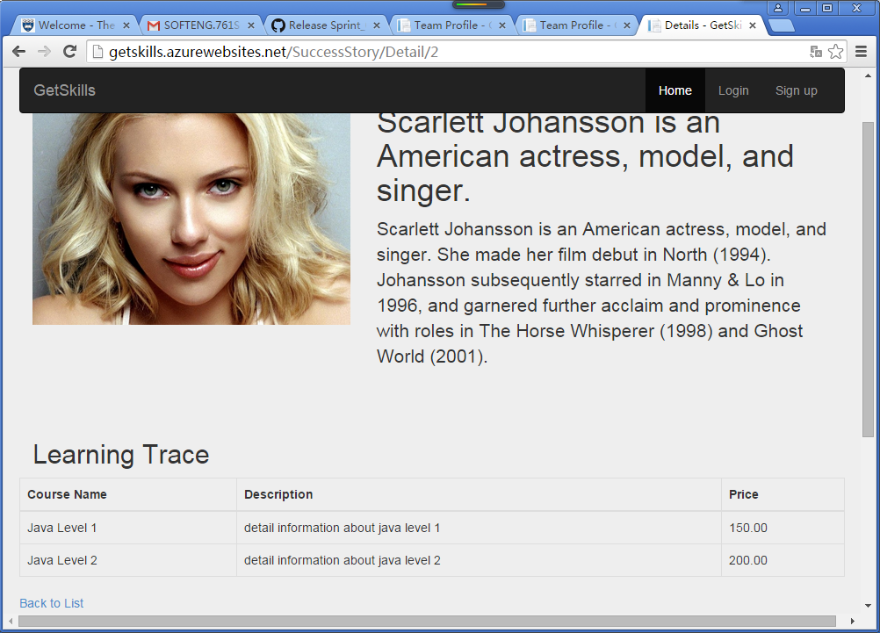

1. User Story 4: As CEO, I would like our team profile and FAQ to be well noticed.

** At the bottom of the Home Page (<http://getskills.azurewebsites.net/>), the ‘Team Profile’ link will lead visitors to the Team Profile Pages

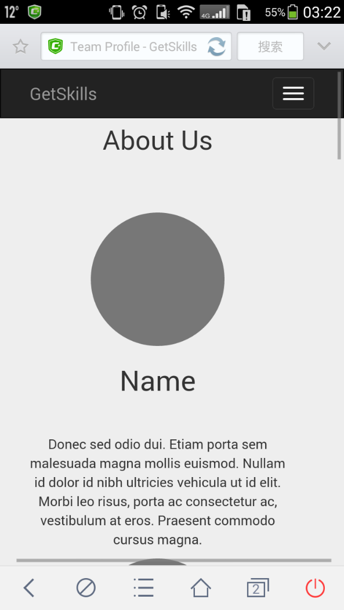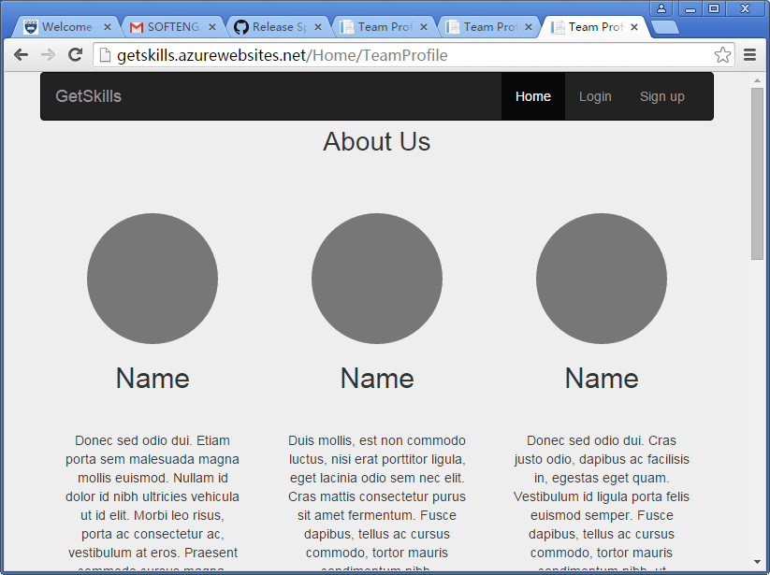URL: <http://getskills.azurewebsites.net/Home/TeamProfile>

** At the bottom of the Home Page (<http://getskills.azurewebsites.net/>), the ‘Team Profile’ link will lead visitors to the Team Profile Pages

URL: <http://getskills.azurewebsites.net/Home/FAQ>

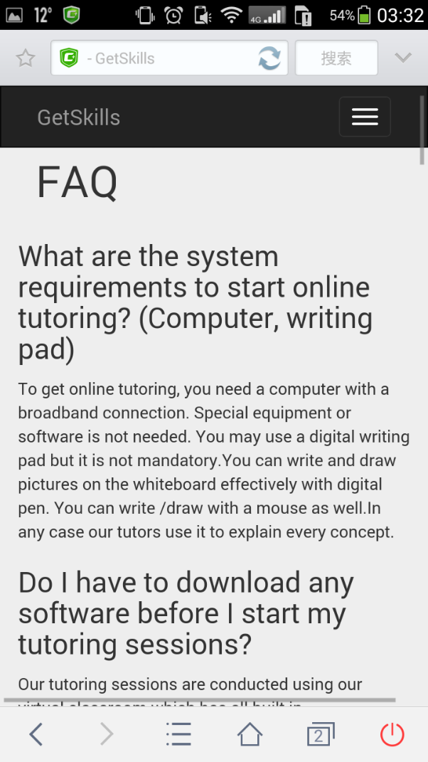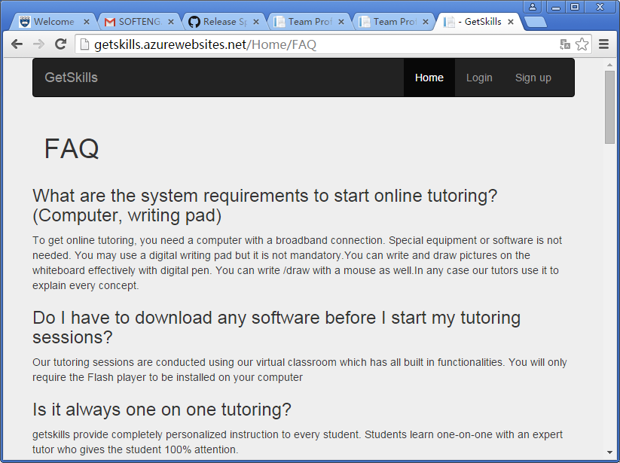

1. User Story 5: As an ADMIN (course advisor), I would like to maintain success stories with Add, Update, and Delete.

** For ADMIN functions, Product Owner informed us that they won’t maintain the stories by using mobile phones. So that we only developed the PC pages.

** Based on security considerations, we decided not to show the ‘Admin Login’ link on public website pages. Administrators can login to ADMIN pages through the link – <http://getskills.azurewebsites.net/Account/AdminLogin>

(UserName: aaaa Password: 123456)

1. Admin URL: <http://getskills.azurewebsites.net/SuccessStory?sortOrder=ID_asc>

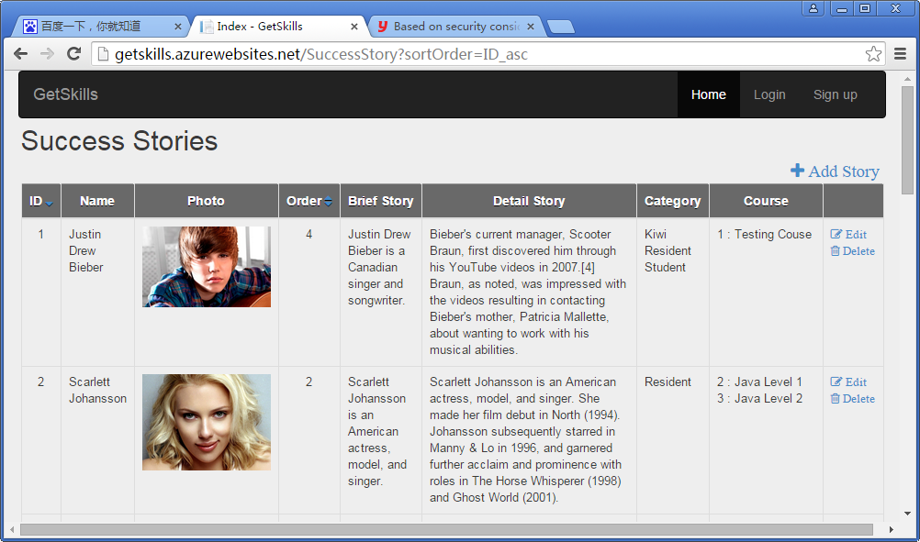

1. By click the “+ Add Story” on Admin pages, administrators can create new success stories.

URL: <http://getskills.azurewebsites.net/SuccessStory/Create>

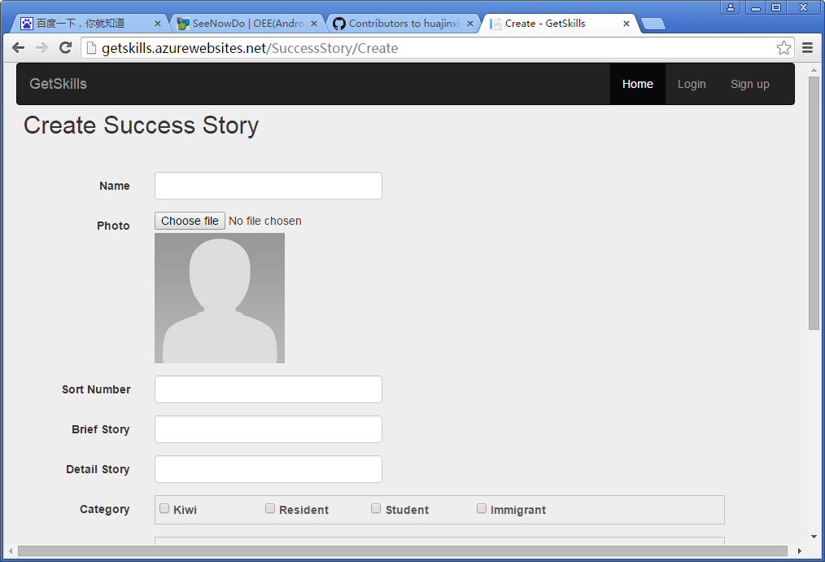

1. By click the “Edit” button after each success stories on Admin pages, administrators can edit exist success stories.

URL: <http://getskills.azurewebsites.net/SuccessStory/Edit/1>

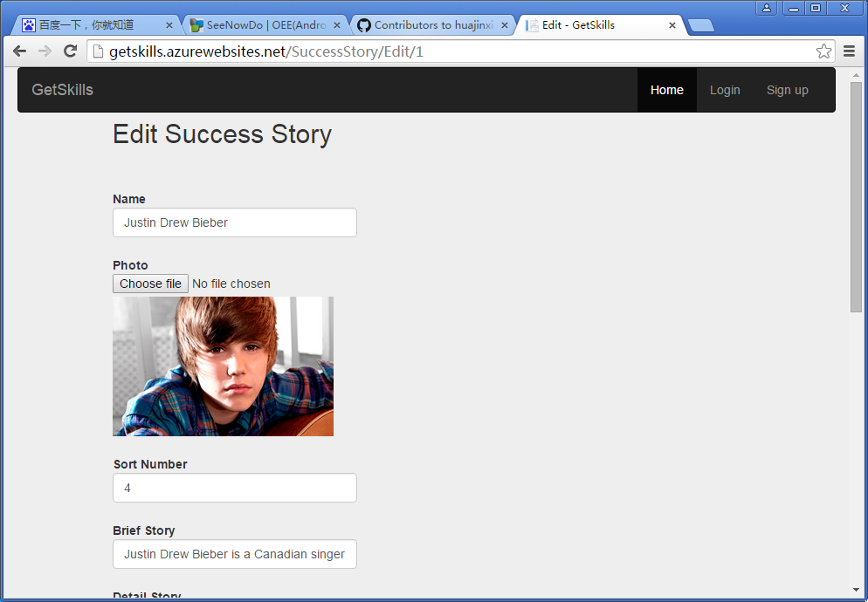

1. By click the “Delete” button after each success stories on Admin pages, administrators can delete exist success stories.

URL: <http://getskills.azurewebsites.net/SuccessStory/Delete/4>

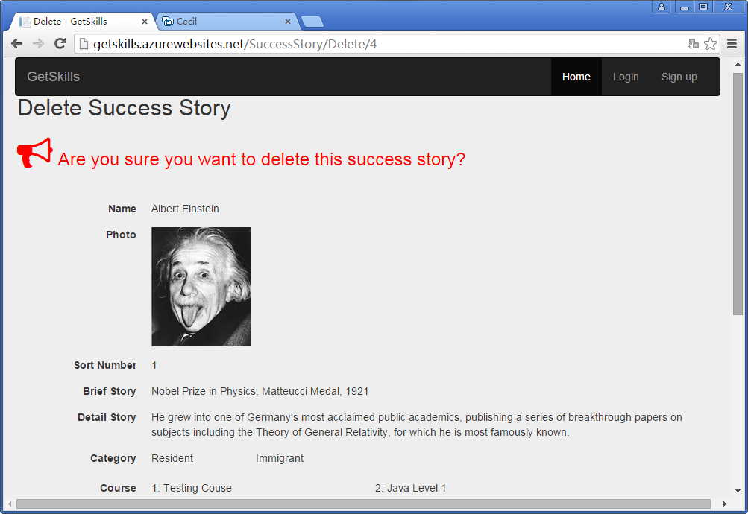

1. User Story 6: As a USER, I would like to login to my category (Admin or Students) in the system.

** No matter which pages visitors are surfing, they can always login/Register in the website by click the related links on heater (Navbar). They can also choose to login by using Google Accounts or Facebook Accounts.

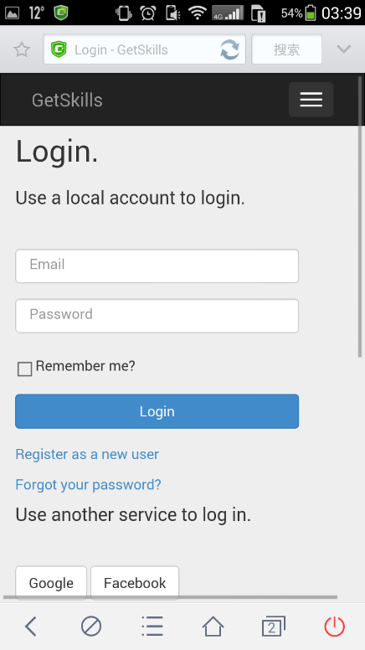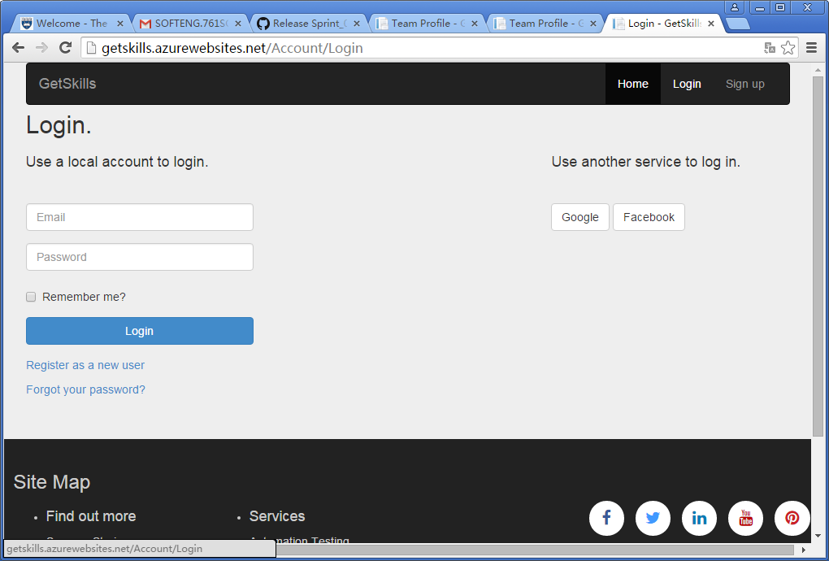URL: <http://getskills.azurewebsites.net/Account/Login>

.

NUnit Tests

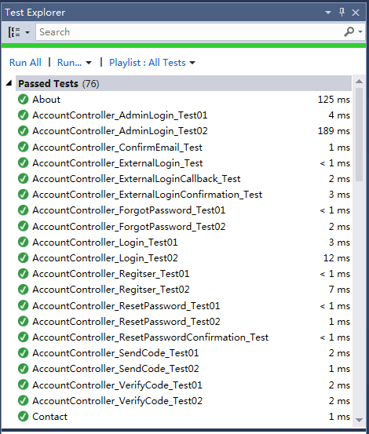We mainly use Nunit, which is an open source unit testing framework for Microsoft .Net, in completing the test cases and Unit tests processes.

In our project, Unit testing for Web Page are implemented. And NUnit testing are implemented for all Controller Classes and methods. Our tests also including sync unit tests.

The methods in controllers have been tested as more as possible. The source codes have passed all of the 76 test cases.

Mobile Friendly Test (Google)

• Test result of old system: Un-friendly • Test result of new system: Mobile friendly

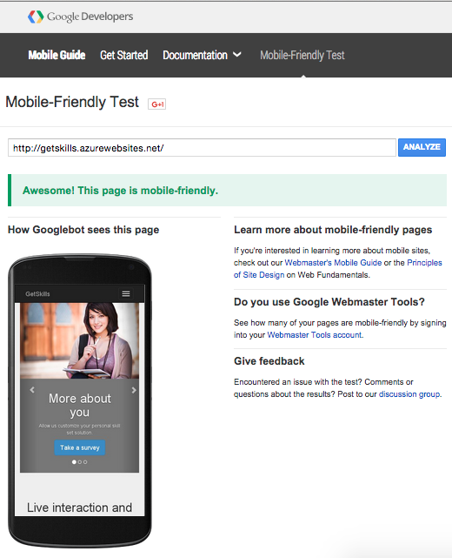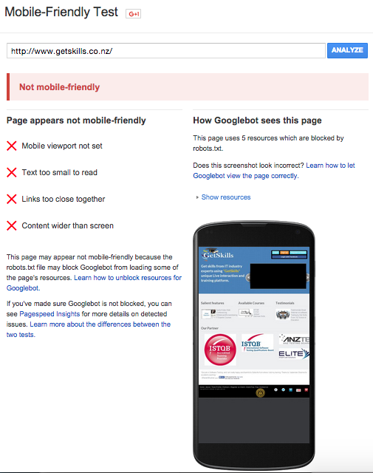

Scrum Management

We use SeeNowDo (URL: [https://www.**seenowdo**.com/](https://www.seenowdo.com/)) as our Scrum management tool.

* Main board

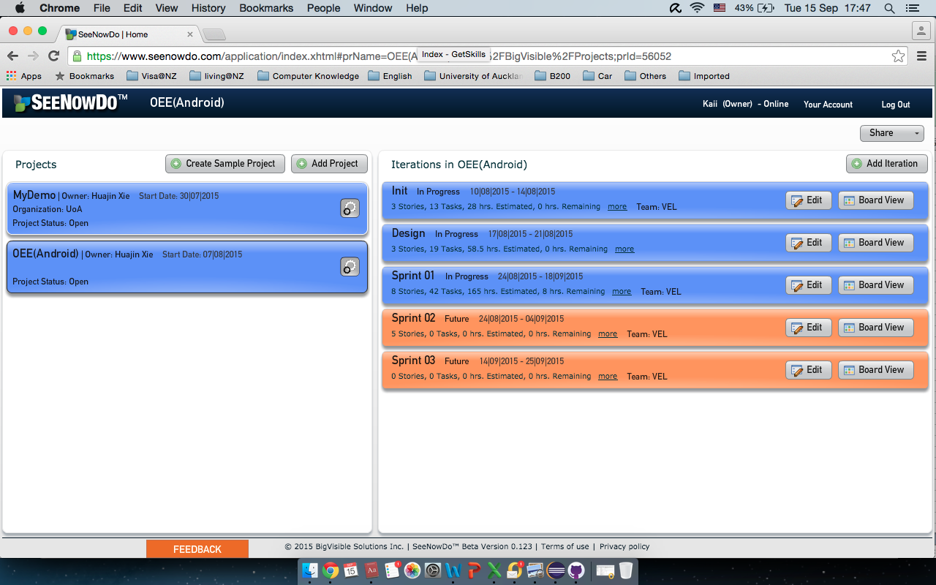

* Scrum Board (Sprint 01)

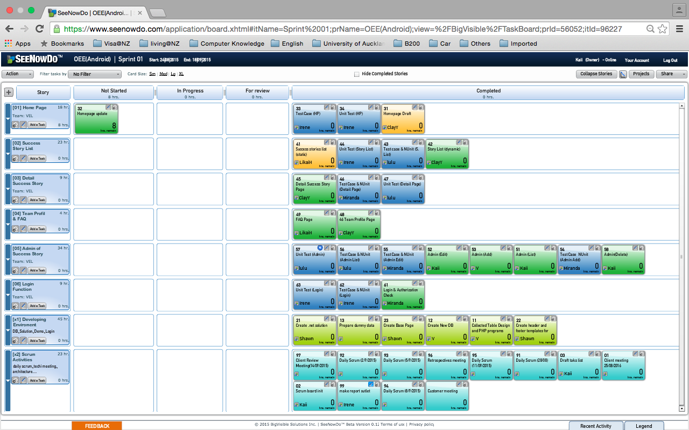

* Burn-down chart (By hours)

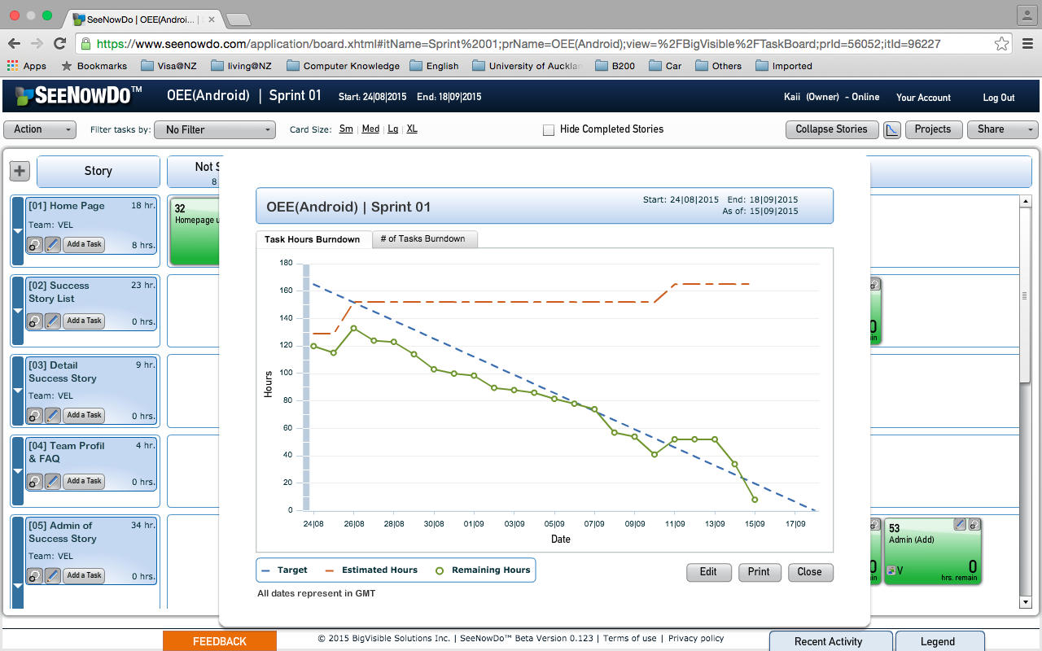

* Burn-down chart (By tasks)

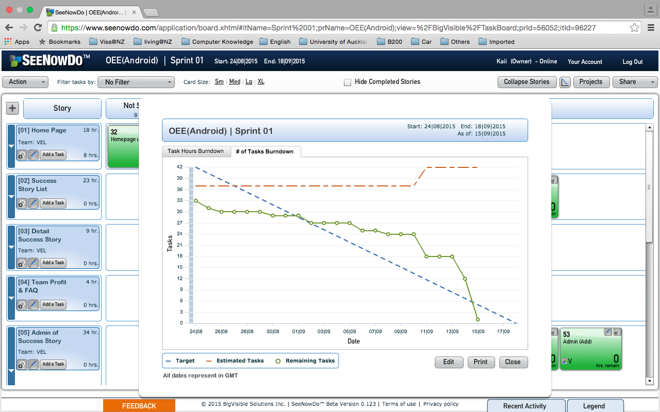

Sprint Review

Our team had a Sprint Review meeting with the attendances of Scrum Master, team members and Product Owner–Yadwinder on September 14th. We’ve displayed our prototype to client. We’ve get positive feedbacks on most of our efforts for the project.

Product Owner–Yadwinder inspected the project and give us four suggestions in adapting the Prototype.

1. Team Profile pages need to be more colourful and interactive.

Add LinkedIn profile links of each members on Team Profile pages.

Design and provide Admin Pages for Team Profiles in next Sprint.

1. Shift “contact us” link form the footer to Navbar (Heater).
2. Adjust the pictures and ISTQB logos in Home Pages.
3. Add “share to social media (Twitter/Facebook) function” on Success Story List Pages and Success Story Detail Pages.

According to PO’s suggestions, we will adjust our project by the end of this Sprint on September 18th Fri.

Retrospective

**Kaii:** Cooperate with other team members to apply agile practices in our project; acted as a scrum mater in the first half of sprint one; contributed my main efforts on estimation, system architecture, DB design, layout design, programming, testing and project management; Meanwhile, I still need more effort on the coordination among team members and helping others with technical issues.

**Miranda**: For the second sprint, I focused on the team profile pages, including the dynamic page for website’s users and admin pages for administrators. Now the administrators can scan, create, edit and delete team profiles. And the users can scan the team profiles for the website. Overall, I created four website pages and refined one page in this sprint.

**Lulu**: In the first week of the second sprint, as the scrum master, I organized the sprint planning meeting for our team. My major task is to refine the success story list page. Now the users can scan the success stories according to their categories. In addition, I completed the unit test for test automation.

**Shawn**: In this sprint, I integrated APIs of Facebook, Twitter, Google and LinkedIn to our project, successfully implementing share buttons for social networking. Meanwhile, I also added LinkedIn links for each member in the team profile page.

**Likai**: In this sprint. I focus on the test. I learned how to write a test case and how to use Nunit to test code. I have two test at beginning but one of them cannot be implement, because the customer delete his requirement, so I supplement some test case from last sprint to make them better.

**Clay:** In this sprint, I created test automation page, finished design and development tasks. Meanwhile, I managed to polish home page, changed its layout, updating action buttons. I got the feedback from tester, which is contributed to the project. It's very helpful to have team working around, so that we can achieve a better outcome.

**Irene:** In the second sprint, my task is to develop website counter which can record visitor statistics. I've tried many ways in implementing the task and finally achieved at an acceptable solution. During the second sprint, I've got more familiar with the agile development processes and adapted with the pace of Scrum.

**V:** Push (from testing) and pull (development) from our VEL team helped me to complete the work successfully. EGO is one thing that went away from me in the project, which is key for Successful as a Team. ‘Appreciations’ is another good thing that I made to our team members.

Group Evaluation:

In general, our group did a good job for the first sprint. We defined a reasonable sprint backlog and followed SCRUM process strictly. Everyone got one task at first and after finished it he/she could get another task. We held stand-up meetings regularly so that we could know each other’s progress and obstacles. If anyone had a problem, others would help him/her. Some of us did not have programming experience before, so their progress might be slow. But everyone tried to finish the tasks as soon as possible and make the project perfect. Besides, every scrum master communicated with our customer as much as possible to ensure that the project could meet the demands.